**Group 48 - CSE 535 Mobile Computing Project 2 (Fall 2022):**

**Proposed System:**

1. An artificial neural network is trained using a Convolutional neural network architecture and loaded with MNIST Dataset.
2. The parameters used in our Architecture are batch size 128 and epochs 15.
3. The Deep Learning framework used is CNN.
4. Dimensions of the image used are 28 X 28 pixels and a depth of 1.
5. The final Accuracy achieved is 99.22%

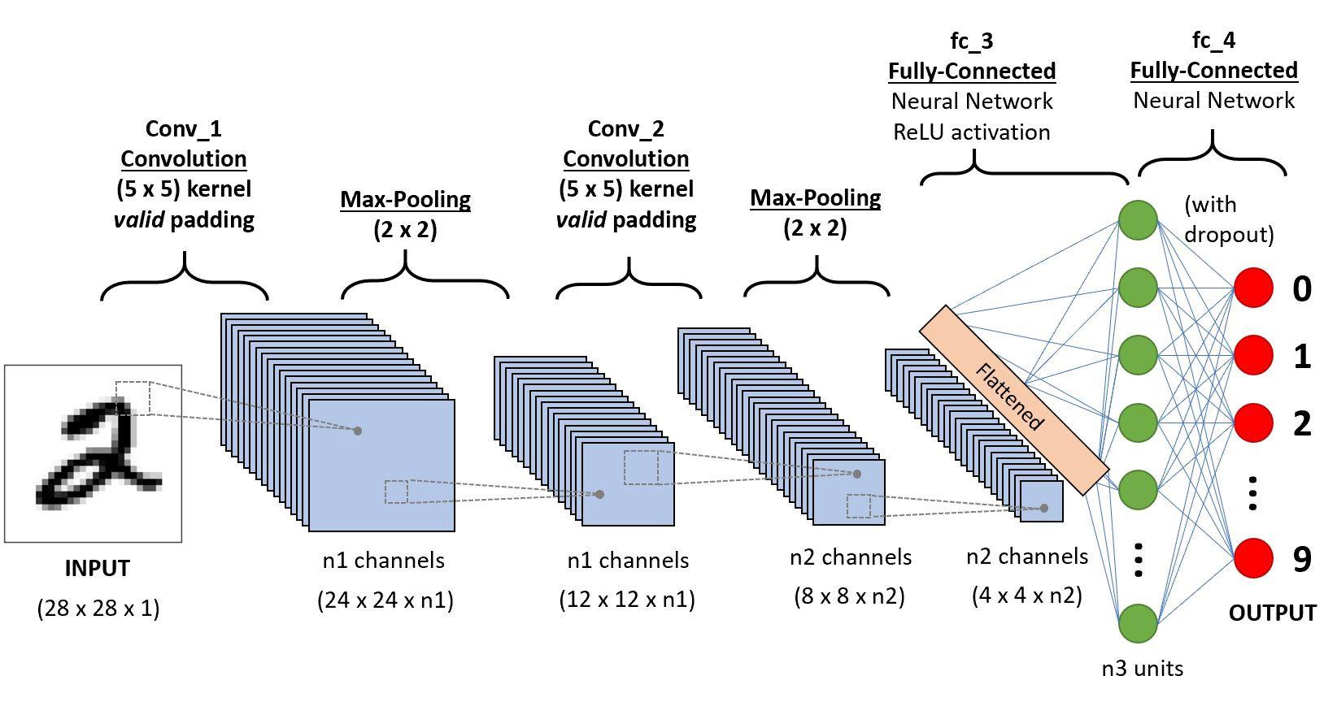

**Steps to run our Application:**

1. Install Tensorflow
2. Install Pillow
3. Run the Training model. (training.py)
   1. The input of the MNIST dataset
   2. Convolutional 2D Network–A two-dimensional convolutional layer for the tensor outputs
   3. Max pooling– A two-dimensional max-pooling layer is added to reduce the heavily loaded dimensions of the feature map
   4. Another Convolutional 2D Network added
   5. Another max pooling layer is added
   6. Flatten layer– Reducing the dimension to the 1D layer for the dropout layer
   7. Dropout layer– A layer used to zero some points to maintain the balance of the network.
   8. The model has been compiled
4. Run the Prediction file. (predict.py)
   1. The model has been loaded into the flask framework. Basic preprocessing is done before the data is actually fed to the model, where the data processing involves:
      1. Converting the image to greyscale
      2. Resizing the image to 28x28
      3. Converting image object to NumPy array
      4. Restructuring from 28x28 to 28x28x1
      5. And finally making it an array of images
   2. Then the model is used to predict the desired output
5. From the application, the scanned number will be appropriately stored in the correct folder.

**Versions:**

Python - 3.9.12

Tensorflow - 2.10.0

Pillow - 9.0.1

Flask - 1.1.2

NumPy - 1.21.5